TRANSNET FREIGHT RAIL
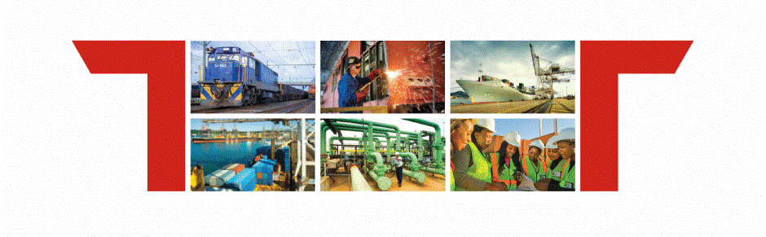

Facility Profile:
UPINGTON

ANNEXURE A: FACILITY profile

 | Siding Name | Siding Number | Land size (m2) | Market related rental | Wagons | Siding capacity (TEUs)
1 | Upington siding | 201219 | 57 841 m² | R170 000 | 40 wagons | 40 000 TEU’s per annum (800 000 tons)

